Grumman Widgeon
Multi-Engine Seaplane
Study Guide
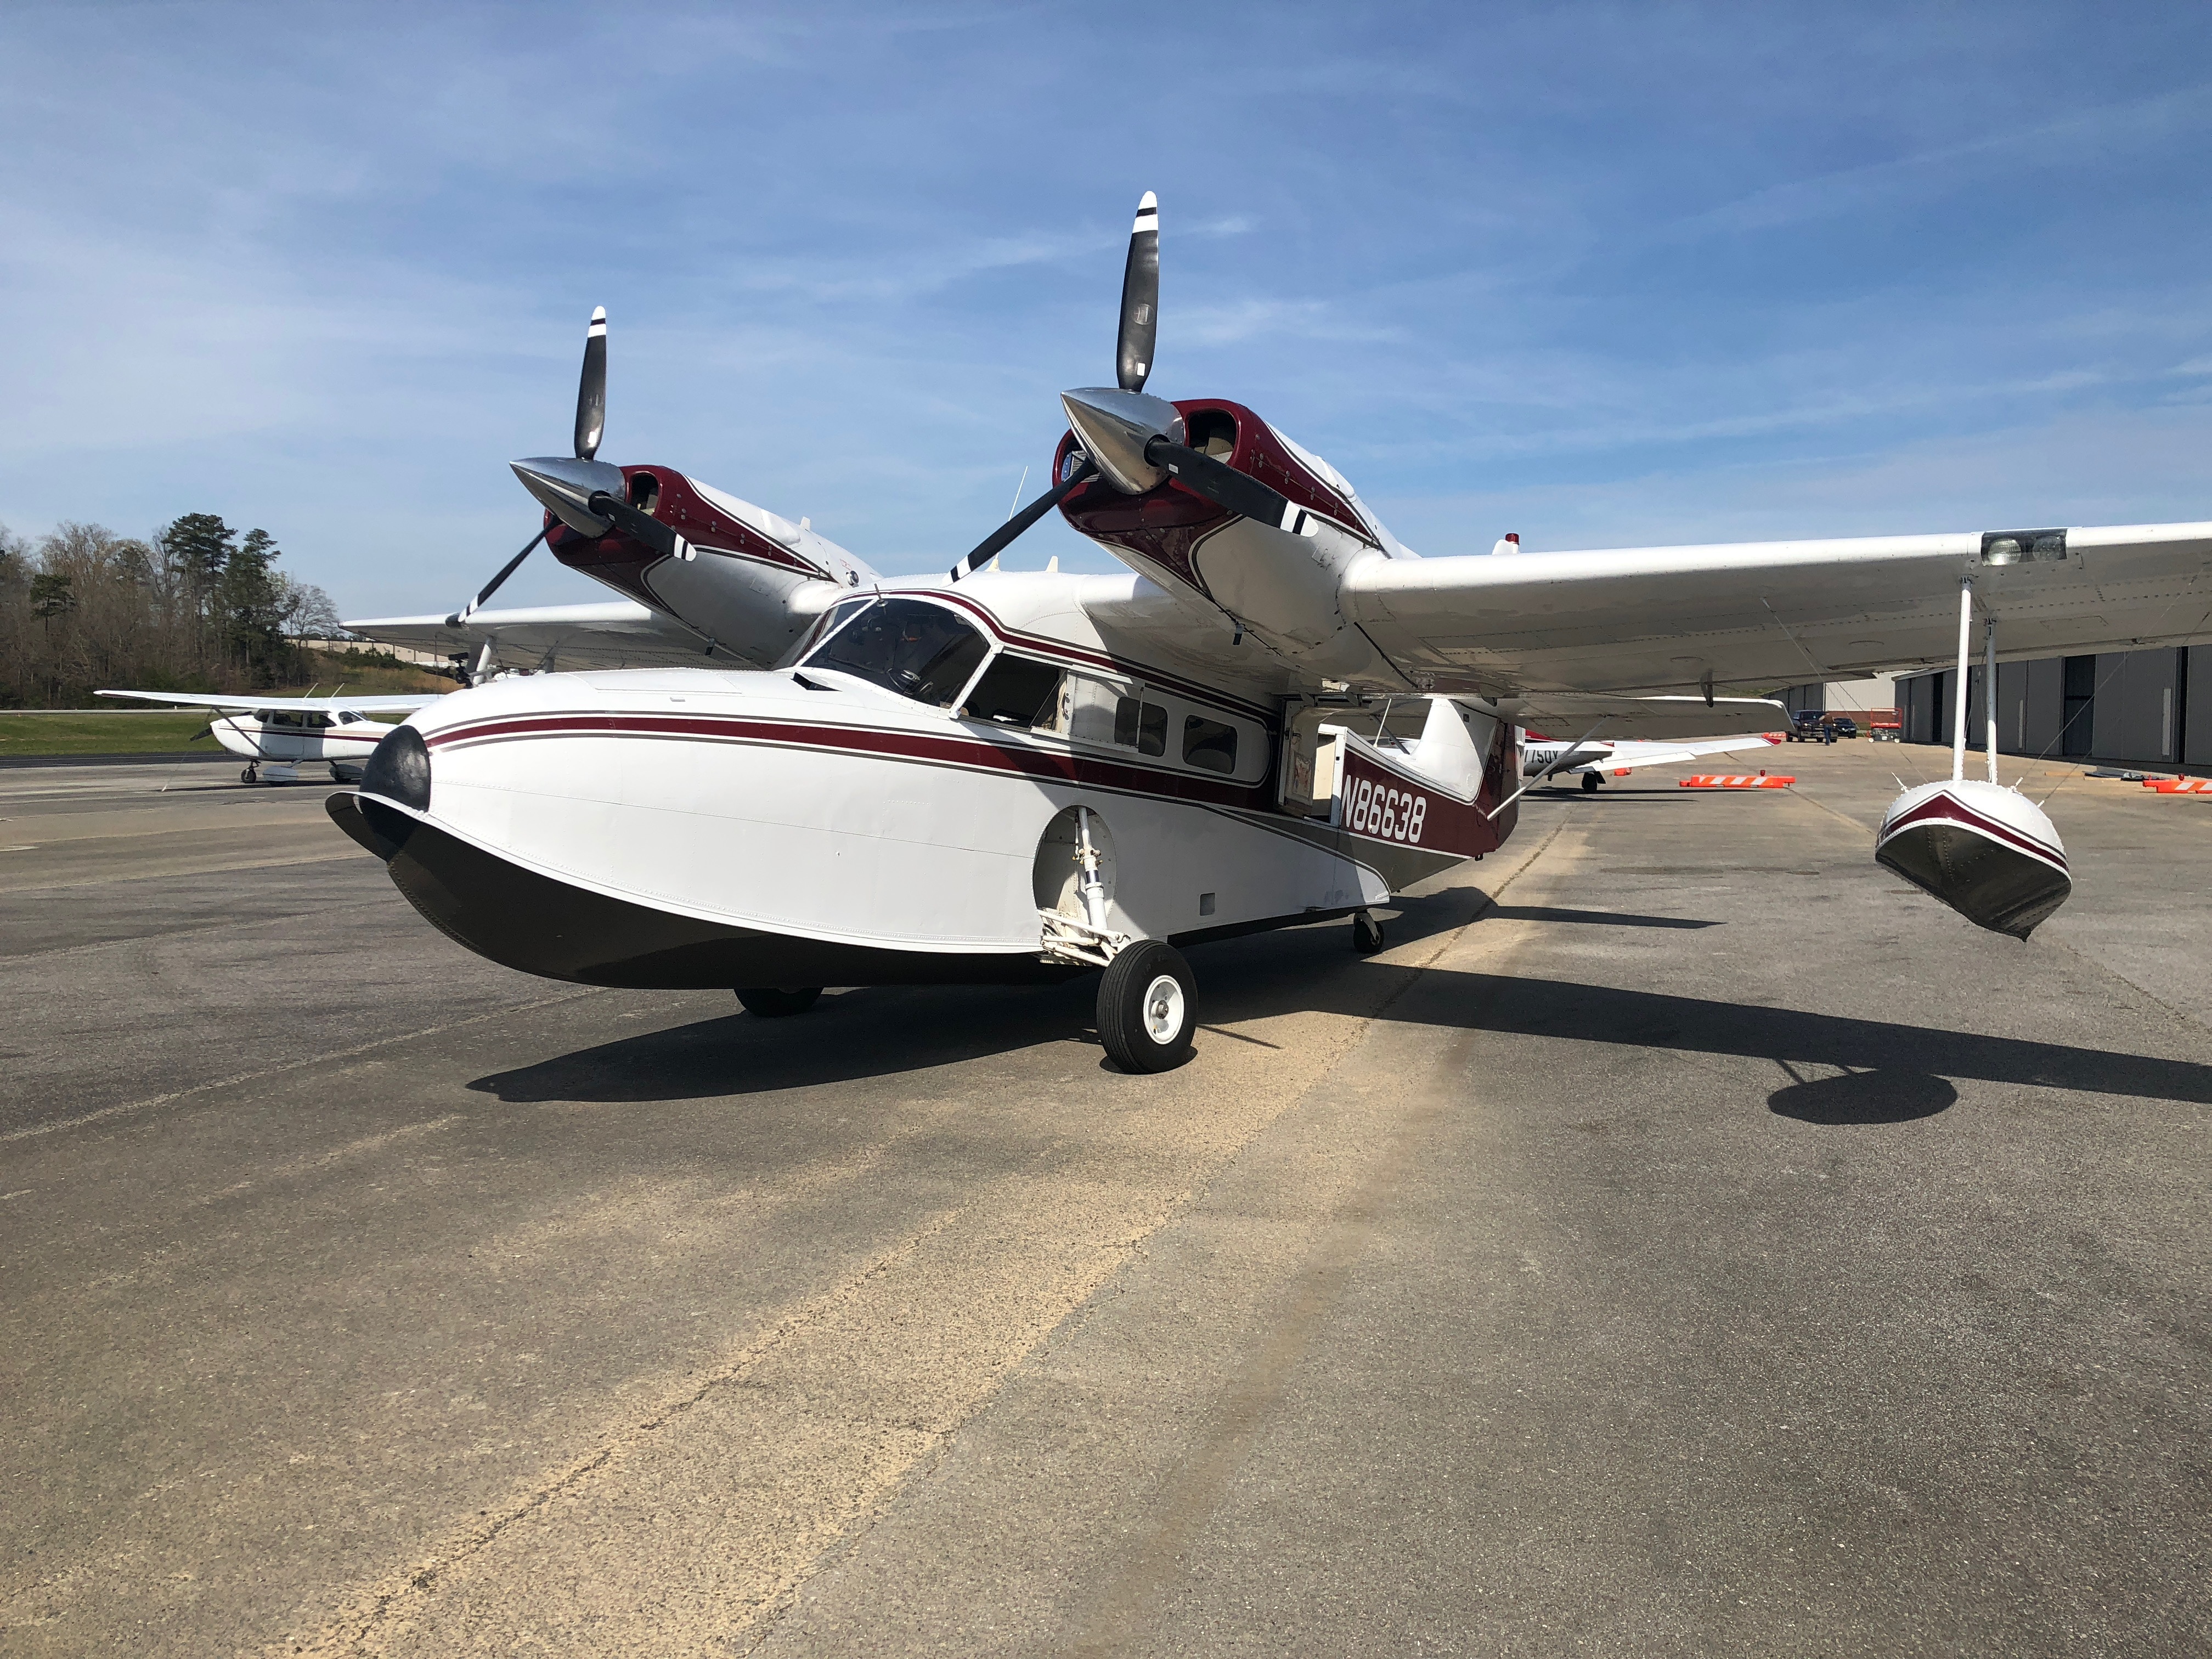

1- Land Operations and GUMPFTS
2- Water operations, Porpoising and skipping
3- Taxiing On The Water
4- Normal and rough Water Operations
5- Glassy Water Operations
6- Mooring, Docking, Beaching, Ramping, and Sailing
7- Air Work
8- Emergencies- Engine Failure
9- Critical Engine
10- VMC , Beauford scale
11- Flight profiles
12- Seaplane study Quiz
13- Operating Manual Quiz
14- Seaplane study Quiz Answers
15. Operating Manual Quiz Answers

LAND OPERATIONS

TAXIING
A slow taxi speed is required to maintain control of a free-castoring tail wheel aircraft. The rudder has little effect at such slow speeds so differential power and brakes are used for directional control. To aid in taxiing long straight taxiways you can lock the tail wheel and keep the downwind engine at or near idle power.

LAND TAKEOFF
After run up and a pilot briefing about V speeds, emergencies, etc., taxi into position, lock the tail wheel, smoothly add power while releasing the brakes, maintain directional control with the rudder. Raise the tail when the airspeed comes alive (somewhere around 25 mph), continue acceleration to VMC + 3 mph (81), then lift off and use a shallow climb angle that will give you both acceleration and climb. Vx for obstacles otherwise, Vy (100 mph) should be used. Gear up at positive rate of climb, throttles 25”, props 2500, flaps up upon reaching Vy at a safe altitude, and boost pumps off at 500 feet agl.

GO-AROUND
This applies to both land and water operations anytime you need, (bounced landing), go around, add power, immediately reduce the flaps to between 10 degrees, check gear up, then, when the speed reaches VY retract the remaining flaps.

The GUMPFTS check list is used before starting any new event such as take off or landing
G gas on, cross-feed off (only two levers are to be on at the same time)
U undercarriage (water)-up, gear handle up, light (up), hyd. pres, mirror, locks
M mixture - rich
P props forward (preparation for a go-around), best done at reduced power
F flaps set 10 degrees for take -off, 15-30 for landing
T trim-set
S stick- full aft against the stop for takeoff or for getting onto the step, aileron right to counter torque, rudder as needed to maintain a straight course

WATER OPERATIONS

DEPTH PERCEPTION
Depth perception is very important to landing in water. If you look too far ahead you may fly into the water and if you look too close you may never get close to the surface, you will stay too high, so don’t fixate on any one object and look ahead about 100 yards.

PORPOISING
Porpoising is dynamic instability on the water, which may occur under certain conditions during either take-off or landing. It is characterized by a rhythmic rocking motion, like a rocking chair. On takeoff it will become increasingly violent unless a quick change in trim angle is made with the elevator, or abort and start over.
Porpoising usually starts when the attitude (trim angle) is either too high (nose up) or too low (nose down); there is a small range for proper trim angle. On take-off as the nose comes up to the second rise and you “go over the hump”, it is important to ease the nose down onto the “step”. Holding the nose up too long or helping the airplane onto the step by easing the elevator early will reward you by immediately entering porpoising, IE: ease the nose down gently so that the seaplane’s nose doesn’t strike the water’s surface hard and bounce off causing the plane to porpoise. Avoid your wake and other waves on take-offs and landings. When landing, wait to raise the flaps, just before dropping off of the step, not at high water speeds or it could quickly pitch up and start to porpoise.
Other operational factors, which change the trim angle limits, are:
1. High gross weight- increases displacement- raises the lower limit considerably
2. Flap position: lowers the upper limit at high water speed.
3. CG position: Forward raises the lower limit at the hump and high speed, aft CG will decrease the upper limit, especially on landing.
4. Trim tab in the wrong position may get the plane into porpoising.
5.Touchdown at or near stall speed: Up angle (attitude) between the water and keel at stall should be about 7 degrees, at faster speeds this is reduced to a dangerous nose down attitude, causing violent Porpoising, snatch downs, and water loops.

It all boils down to maintaining the proper TRIM ATTITUDE at all times!

SKIPPING
Skipping is an up and down motion which is done at higher speeds, similar to skipping a stone across the water. Normally started by waves on the step with an excessive nose high attitude, power, and speed. Proper attitude for takeoff, step taxiing, and landing on the water is necessary at all times! Wetting the aft hull section could cause suction pulling it down and suddenly releasing the plane into the air below stall speed. Step vents help to relieve the suction problem and lift off in a shorter takeoff distance.

TAXIING ON THE WATER
IDLE
Idle taxi is generally considered to be the best form of taxiing because it is slow and we have good visibility, fair cooling, no spray problem, and good maneuverability especially with the gear down. Turning is accomplished by using short bursts of differential power. Aileron position during idle taxi is more important on the water than on the land because we do not have the landing gear to keep the wind from lifting the upwind wing and sinking the leeward wing float and possibly capsizing the seaplane, especially in the downwind to upwind turn.

STEP
Step taxiing is used to transition long distances because of the speed. Wind and waves should be calm enough to keep the hull from banging too much. During step taxi we have good visibility, cooling, and no spray problem. Use takeoff Power to get up to the “second rise”, and as you go over the “hump” ease the nose down onto the step, reduce the power to maintain the step taxi speed. Turning is achieved by using rudder pressures. During an aggressive turn you may have to increase the power to stay on the step because some of the energy is used up by the centrifugal force, this will be evident as the seaplane starts to “bobble” and porpoise. Keep the wings level and use a slow rate of turn, don’t be in a hurry. Caution must be used in a step turn from downwind to upwind as centrifugal force and the wind work together to capsize you especially on float planes.

NORMAL WATER LANDINGS
Upon reaching your destination water we over-fly the intended landing spot at patern altitude to check for wind direction, hazards ie: wires, boat traffic, logs, submerged objects, depth, etc. When we are satisfied that it is safe and having picked out the best “landing lane” we enter downwind around 750 feet AGL and then we use the GUMPFTS checklist while slowing to flaps speed, then drop 10 degrees flaps, maintain “blue-line”(95), at 45 degrees turn base, drop 10 more flaps, check the area and turn final. Drop 10 degrees more flaps, (20 normal) maintain blue line till the water is made, then reduce your speed to 85 mph, (you do not want to get near the water surface at a high speed), about 5-10 feet above the surface transition to the landing attitude, (forward nose area parallel with the horizon or lake surface). Power should be maintained at 12”- zero thrust, speed about 75 mph and decreasing, touchdown should be just above a stall (65 mph with 20 degrees flaps). Never enter the water bow low or with a side drift, take your time. Once you have touched down, and not (skipping), reduce all power, ease the stick back, as you are dropping off of the step remove the flaps, and close the windows.
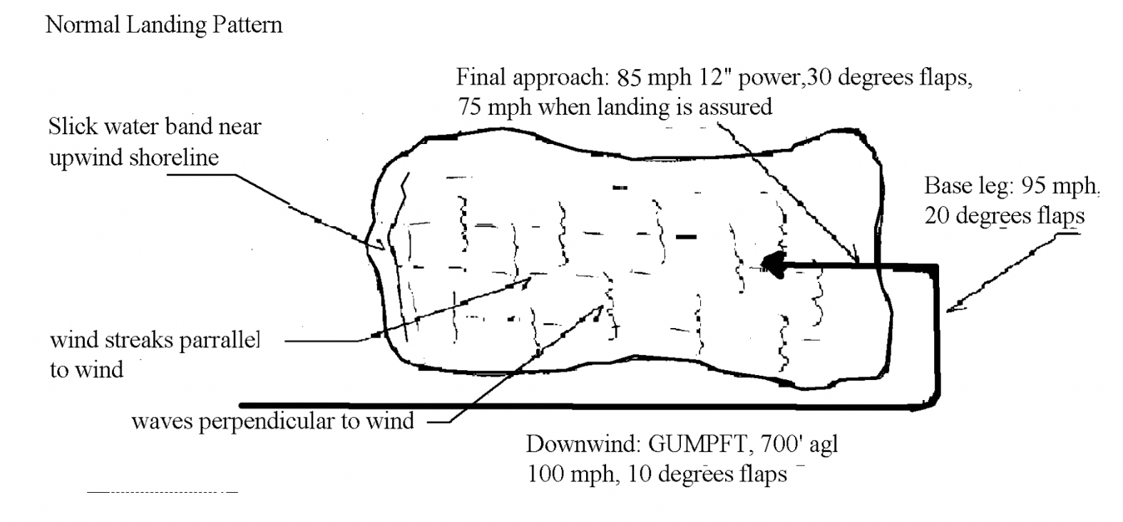

NORMAL WATER TAKEOFFS
Use the same procedure as getting on the “step” and continue with full power. ie. GUMPFTS (stick full back, aileron right, right rudder) ease onto the step, accelerate to 62 mph with the proper attitude same as (landing) and let the seaplane lift off when it is ready to fly, don’t force it off, since you’re already way below VMC. Once free of the surface you will accelerate quickly and climb at the same time. It is important to hold the proper attitude, (as landing), while maintaining a shallow- climb just in case of wind sheer, engine out, etc. Let the speed increase through VMC and Vx to Vy. Care must be taken not to touch down again after takeoff at the wrong attitude, when speed and altitude permit, reduce to climb power and flaps up.

MAXIMUM PERFORMANCE TAKEOFF
Short water takeoff with this seaplane is done like a normal takeoff except that we use 10 degrees of flaps to get off the water in less time and distance. Lift off at 62, initial climb at vx (81) to tree top height, then vy 100. One procedure some pilots use is to get onto the step crosswind and then step turn into the wind and takeoff, useful with some underpowered seaplanes and a wide lake, but may be hazardous to the inexperience pilot and narrow waters.

SHORT FIELD/WATER LANDING
Short field/water landings can be made with 30 degrees of flaps maintaining speed and approach angle. Do not approach too slow or you may not be able to transition at the bottom and impact the water harder than you anticipated. Nose up trim is needed with 30 degrees flaps, beware of the excessive pitch up on go-around.

ROUGH WATER TAKEOFF
Takeoff is the same as normal except we use 10 degrees of flaps for a shorter run and we use a slightly higher nose attitude so we will become airborne at the minimum speed possible, accelerate in ground effect, hold the proper “attitude” while climbing. On small bodies of water a crosswind / downwind arch procedure in the lee of trees on the upwind shoreline is usually the best choice, calmer water and less wind.

ROUGH WATER LANDING
Pick the calmest area, touchdown as slow as possible just above a stall, nose angle slightly higher than normal you may want to land “across” the waves not “straight on”. At touch down power back, flaps up as you come off the step.

CROSSWIND TAKEOFFS
On cross-wind takeoffs you can use the downwind arch procedure, start about 45 degrees into the wind from the left, get on the step, then start a downwind arch turn to the right, the centrifugal force in the turn will help keep the upwind wing down while compensating for weather-vaning, lift off while in the turn. See illustration below.
We put the wind on the left because torque will help keep the upwind wing down as well as visibility of the waves is better looking out the left window.

CROSSWIND LANDINGS
Slipping down to transition height is one way, or use the same procedure as the takeoff, using the centrifugal force in a downwind arch, see illustration below.

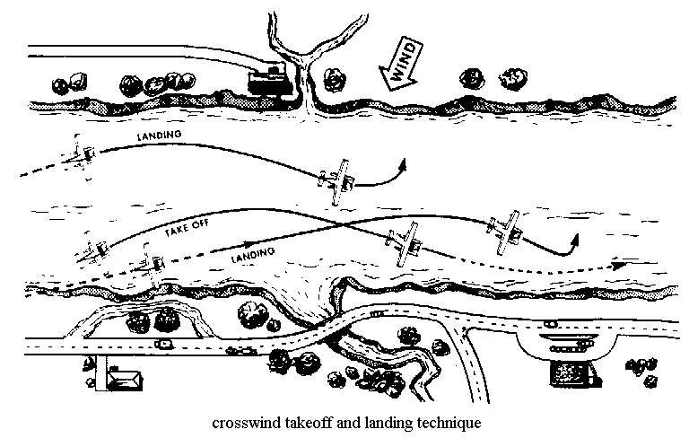

GLASSY WATER TAKEOFF
Takeoff is the same as normal, unless short water is involved, then it may be better to ripple the water first by taxiing around in the takeoff area. The waves will help break the suction smooth water makes upon the hull. It also may be prudent to takeoff along the shoreline for altitude reference in the climb so you will not fly back into the water.

GLASSY WATER LANDING
Landing in glassy water takes a special procedure, i.e.; using only 15 degrees maximum flaps (more would lower the trim angle and a touchdown would be disastrous), we look for a “LVR” (last visual reference point) along the shoreline finding the lowest area. Turning on a long final we approach the LVR as low as possible with a speed approaching 80 mph keeping the power around 12”, at the LVR we pitch up to our proper landing “attitude”, maintain 75 mph, bring in the power to 16” plus or minus to give us a rate of decent of 100-150 ft. per min., hold this configuration until touchdown do not flare, power changes as necessary, this is a precision approach. On touchdown roll the power back, hold the attitude. As we slow down flaps up and stick back. If there is excess speed at touchdown the plane may pitch down from, be ready for it, but don’t yank the plane back into the air. If you do get airborne, go around, and return for another landing.
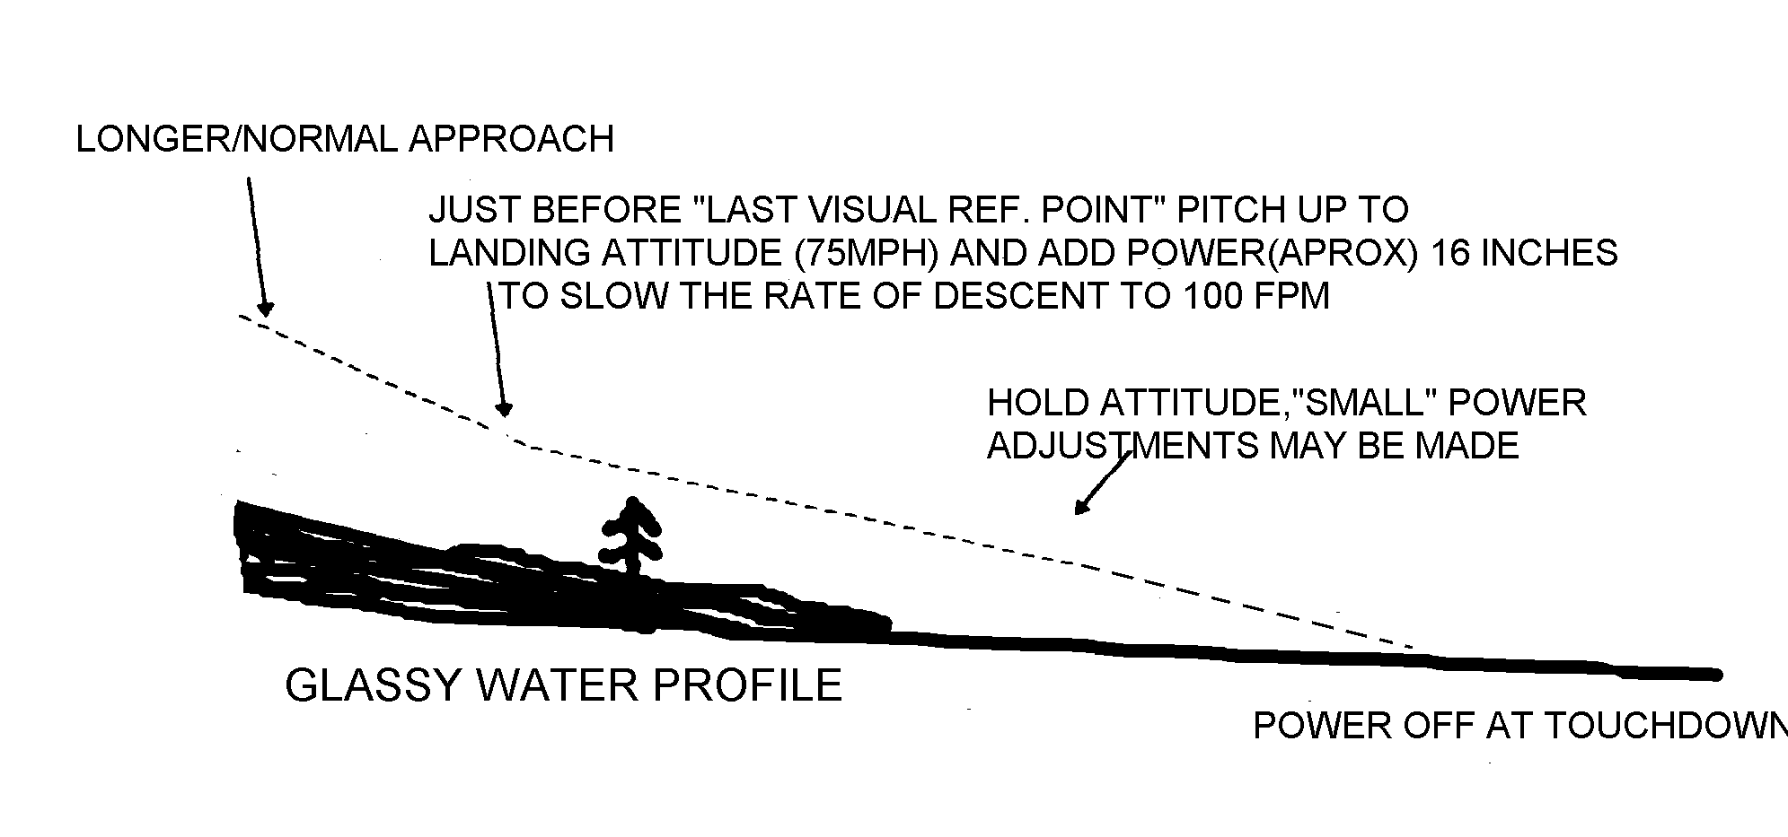

HIGH DENSITY/WEIGHT TAKEOFF
Simulated with 60% power a partial power, high density alt., gross weight takeoff this maneuver will show the student the difficulty of getting on the step and finding the proper trim angle until rotation speed. Then a quick pitch up into the air can be made to get airborne keeping the seaplane from decelerating and prolonging the takeoff run.

MOORING
Brief the helper about the props before they open the forward hatch. Approach into the wind, having the gear down will help slow the seaplane. Upon leaving a mooring you may choose to “sail clear” first, since the plane will start to move immediately when the engine starts.

ANCHORING
Anchoring is essentially the same as mooring, after the props stop turning lower the anchor using a scope that give a ratio of seven feet of anchor line to one foot of water depth.

DOCKING
Approach a dock slowly - gear down - bumping the mags and shut down the engines before coming too close. You should nose up to the dock and exit the plane thru the nose door. If you use the wing tip to exit then it must be protected by use of a helper on the dock to fend off and protect the wing tip. Watch out for pilings.

BEACHING
On your fly-by a careful observation of the beach should be made looking for submerged objects and checking for an area that has a steep gradient .Approach at idle speed, gear down, tail-wheel unlocked, approach at a 45 degree angle to the shore so you can easily return to deeper water if the wheels start to sink in the sand.

RAMPING
Approach at idle, gear down, flaps up, tail-wheel locked,power up the ramp with the stick back. Go all the way up until on a flat surface. Use caution on braking when descending the ramp and use the tail-wheel lock to keep from swinging around.

SAILING
Power off sailing is done similar to float type aircraft. Let the aircraft weathervane, engines off, flaps as needed, place ailerons in the direction you want to go, and use opposite rudder, elevator back, the plane will drift backward in the direction nearly parallel to the keel using the wind and parasite drag.

AIRWORK
altitude at least 1500 feet

STEEP TURNS
clearing turns, add power if needed to 23x23, 45 -60 degree bank, 360’s

SLOW FLIGHT
clearing turns, power back, GUMPFTS, props to 2500,power as required, 20 degrees flaps, 75 mph, recovery - power up, clean up, return to cruise

POWER OFF OR APPROACH TO LANDING STALL
Clearing turns, power back, GUMPFTS, (gear up and flaps 30 degrees), scenario - set up like on “final” airspeed 85 etc. raise nose to imminent stall warning (controls get light) then recover-lower attitude, power up, get flaps up to 10 degrees immediately, as speed warrants - remainder flaps up, back to cruise.

POWER ON OR DEPARTURE STALL
Clearing turns, power back, GUMPFTS, (gear as requested), flaps 10 degrees, when speed reaches 80 mph, power up to 15” pitch up in a slight bank, just like avoiding an obstacle at the end of a runway - recover when you get an indication of a stall, power up, reduce pitch, as speed increases -flaps up, return to cruise flight.

ACCELERATED STALL
clearing turns, power back, GUMPFTS, 10 degree bank, power about 15” add back pressure to maintain altitude as speed bleeds off, recover when you get an indication of a stall, lower pitch, level bank, power up, return to cruise

Vmc DEMONSTRATION
clearing turns, power back, 100 mph, GUMPFTS, (gear up, flaps 10 degrees), left engine idle, right engine takeoff power, pitch up slowly to decelerate, maintain directional control with very little rudder pressure, maximum 5 degrees bank into good engine. When you loose directional control or get a stall indication - recover by reducing the power enough to stop the turn and lowering the nose to gain rudder control as speed and control increases then only use the right engine for recovery – maintain single engine control and speed, add the second engine only after the manuver is completed then return to normal cruise.

EMERGENCIES

ELECTRIC HYDRAULIC PUMP FAILURE
Switch off the electricity to the hydraulic pump and then pump the emergency hand pump handle located next to the pilots left knee and uses a forward and aft pumping action. It directs fluid from the bottom of the reservoir directly to the system without increasing pressure through the accumulator. You must select the gear handle position and pump the gear up or down. For flaps, hold the flap handle in the down position and pump. No pumping necessary for flaps up. Your gear will be locked down only after the handle cannot be moved anymore indicating that the pressure is up.

ENGINE FAILURE

The procedures for an engine out depends on when and where it happens, i.e. on takeoff below blueline - abort the takeoff. After blue line it is at the pilots discretion whether to abort. If there is no available runway left you should go around the pattern and return for a landing, use the most suitable landing area. In cruise you should land as soon as practicable.

SINGLE ENGINE CHECKLIST
When continuing flight the procedures are:

MIXTURES rich
PROPS forward
THROTTLES forward
BLUE LINE
FLAPS up
GEAR up
IDENTIFY dead foot dead engine
VERIFY reduce throttle on suspect engine
FEATHER simulate by pulling the prop back a little bit if this is practice
CALL FOR THE SINGLE ENGINE CHECKLIST to secure the dead engine, 5 degrees of flaps, etc.
These procedures must be memorized and you should be able to go through them at a normal rate.

CRITICAL ENGINE

The failed engine that most adversely affects the handling characteristics of the aircraft is called the critical engine. In aircraft that have all right hand rotating engines the left engine is critical. Four factors that make the left engine critical in this aircraft are: We use the nmenonic PAST

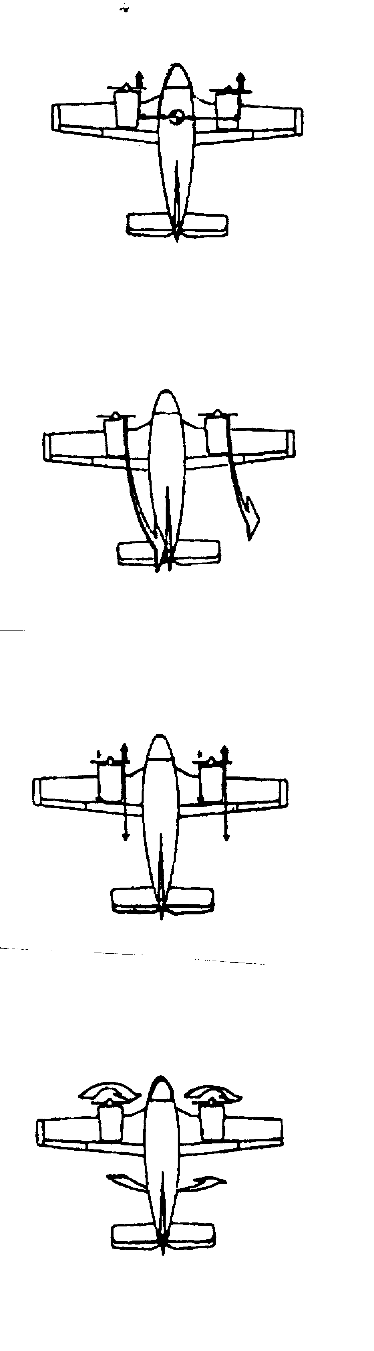
P-FACTOR

The descending prop blade produces more
Thrust than the ascending blade and because
the right engines descending blade is further
out from the center of the airplane than the
left engine it will yaw the aircraft to the left.

SPIRALING SLIPSTREAM

A spiraling slipstream from the left engine
hits the vertical stabilizer on the left side
when the right engine fails.
If the left engine fails the right engine slipstream
will not hit the right side of the vertical stabilizer.

ACCELERATED SLIPSTREAM

Increased lift from accelerated slipstream over the right wing causes the wing to roll the plane to the left because it is further out from the airplane’s central axis.

TORQUE

the plane will yaw and roll to the left if the
left engine fails.If the right engine fails the
plane will yaw to the right and roll to the left
thus helping to cancel each other out.

Vmc
Vmc is the minimum speed at which directional control can be maintained with the critical engine inoperative.

Vmc is determined by the following:
1. sea level on a standard day
2. the critical engine wind-milling, max. drag
3. maximum power on the operating engine
4. flaps set at takeoff position
5. landing gear in the up position
6. the center of gravity that most adversely affects the plane
7. a maximum of 5 degrees bank into the good engine
8. gross weight
9. 150 pounds maximum of rudder pressure

EXPLANATION OF THE ABOVE
1. standard day is used for continuity
2. the wind-milling prop. increases drag and adverse yaw substantially
3. maximum power on the operating engine
4 Vmc is determined at the most critical phase of flight, just after takeoff
6. the rudder is less effective with an aft CG,(the arm is shorter)regular acft.
7. the horizontal component of lift in a bank will aid in overcoming adverse yaw. the amount of bank is limited to 5 degrees for continuity between different aircraft.
8. an increase in weight increases the amount of horizontal component of lift so it actually lowers the Vmc speed.
9. the rudder force required to maintain directional control may not exceed 150 pounds as per. FAR 23.149

BEAUFORT SCALE
# wx term mph indicator sea condition
0. calm 0-1 smoke rises vertically sea like a mirror
1. light air 1-3 smoke drifts ripples (still use glassy. wtr app.
2. light breeze 4-7 leaves rustle wavelets / wind streaks form
3. gentle breeze 8-12 flags extend sparse whitecaps (ideal water)
4. moderate breeze 13-18 dust raises frequent whitecaps
5. fresh breeze 19-24 trees sway many whitecaps (rough water)
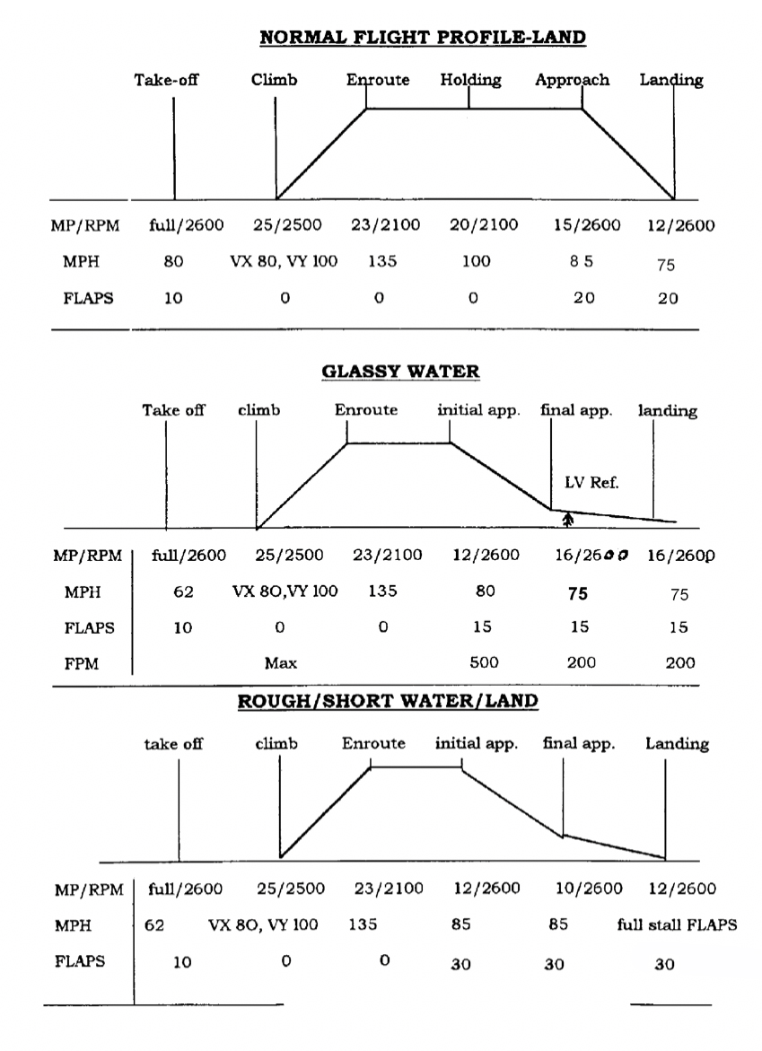

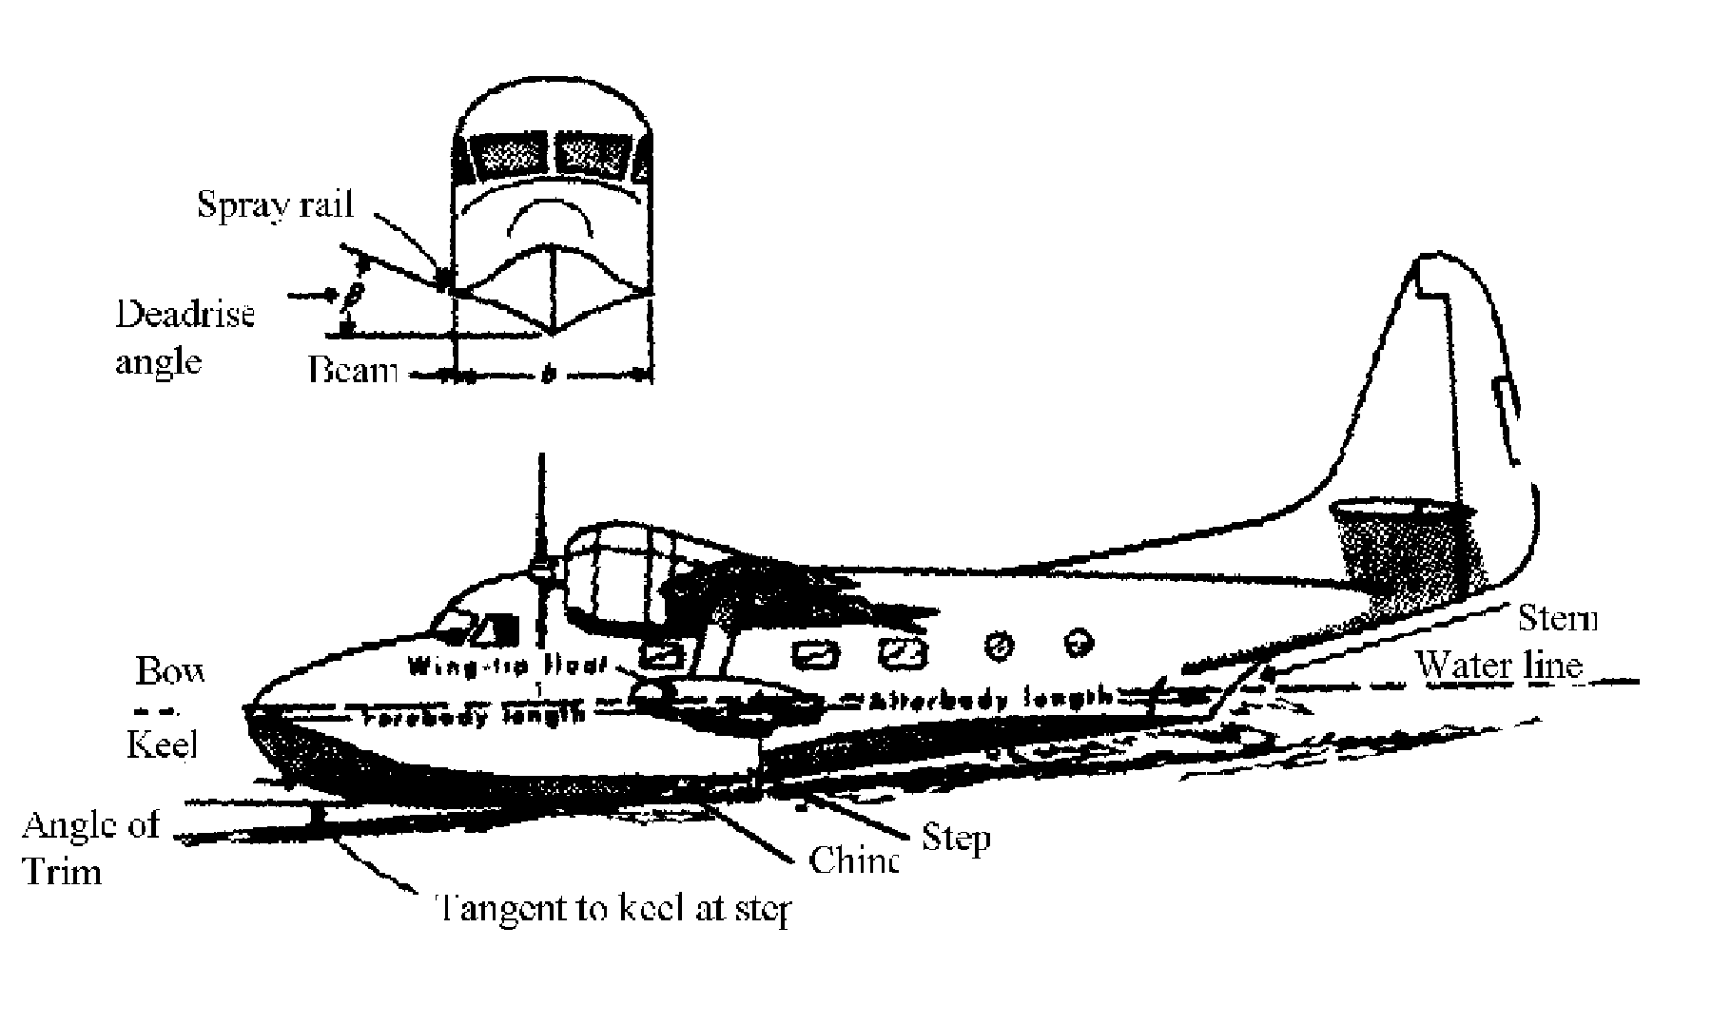
SEAPLANE STUDY QUIZ
1. When step taxiing which is the most dangerous turn that can capsize a seaplane? why?
2. What is the checklist we use before any major operation?
3. What type of water condition is the most dangerous for a seaplane that is landing?
4. What technique do we use for a glassy - water takeoff?
5. What is it called when an aircraft turns into the wind by itself?
6. In which position should the elevator control be in while on the water?
7. When do we use step taxiing?
8. Describe the technique for sailing.
9. Describe the technique for ramping.
10. Describe the technique for beaching.
11. List four reasons a seaplane enters porpoising.
12.What is the best way to determine the wind direction if you are on the water?
13. When flying overhead, how can you determine the wind direction?
14. What method is used to stop severe porpoising?
15. What method is used for glassy water landings?
16. What certificates or documents must be carried in the airplane at all times?
17. What certificates must be carried by the pilot?
18. How long is a second class medical good for?
19. Who has the right of way boats or seaplanes? Why?
20. Frequent white caps occur at what wind speed?
21. Wind streaks start to form at what wind speed?
22. Who has the right of way on water, a seaplane taking off or a seaplane landing?
23. The color of a rotating beacon at a seaplane base is?
24. The symbol on a chart for a seaplane base is? Explain the landing direction
25. What part of the seaplane hull is the most important? Why?
26. What is the most important part of a pre-flight on a seaplane?
27. What precautions should be taken when docking?
28. What causes a seaplane to stall?
29. FAR 91.115 states?
30. Give 5 sources that a pilot can use to determine if the landing area is open
31. What are 5 items a pilot will check for on his fly over?
32. Describe a maximum performance takeoff?
33. How many water- tight compartments does this seaplane have?
34. Why is proper elevator trim important on takeoff?
35. Why should landings be made at or near full stall?
36. Describe crosswind takeoff and landing methods.
37. Which way will the seaplane turn the tightest on water, left or right? Why?
38. What precautions should be taken when water depth is not known?
39. Describe the cause and effect of a water loop?
40. Describe the cause and effect of skipping?
41. The two worst events that can be done in an amphibian are?
42. If you loose a wing float you should do what?
43. If towing is necessary where should you secure the tow line?
44. Where is the best CG for a high density takeoff?
45. which one has steeper/ rougher waves a shallow lake or a deep lake?

OPERATING MANUAL QUIZ
1. Gross weight of the Widgeon is on land? on water?
2. what is the Basic Empty weight?
3. What is the useful load?
4. What is the fuel capacity?
5. What is the normal fuel consumption at cruise?
6. With two engines, what are the service and absolute ceilings?
7. With single engine, what are the service and absolute ceilings?
8. What is the maximum rate of climb?
9. What is the single engine maximum rate of climb at 4700 lbs.?
10. Describe the emergency gear extension procedure.
11. Describe the cross-feed procedure. When do we need it?
12. What is the immediate action on an in -flight engine failure?
13. Under what conditions is VMC determined?
14. What is the go-around procedure?
15. Flaps for normal takeoff on land and water is?
16. What wave height is considered rough water?
17. Which is the critical engine? Why?
18. Which engine has the generator?
19. where is the hydraulic pump located?
20. what is the normal hydraulic pressure in psi?
21. What is the hydraulic system capacity? Reservoir ?
22. What type of brakes do we have? Where are the reservoirs? what type fluid?
23. what is the air pressure for the tires?
24. What precaution concerns the door and flaps?
25. Describe the hydraulic system with reference to the gear, how long to cycle, hand pump.
26. describe the flap system and emergency extension.
27. Describe the electric system.
28. where are the batteries located?
29. Give the following speeds: Vmc, Vyse, Vs, Vso, Vx, Vy, Vfe, Vle, Vno, Vc, Va
30. What is the take off distance on land at 4700 pounds, to clear a 50 foot obstacle
31. When measuring water distance at 90 knots 1 second equals how many feet?
32. What type are the engines?
33. How many drain plug are in the hull? wing floats?
34. How is the bilge pump operated?
35. What is the recommended oil grade and quantity?
36. What is the maximum flap extension?
37. How many psi is in the hydraulic system accumulator? what is its purpose?
38. Why is there a balance on the right elevator tab? How does it work?
39. Can you feather a prop at any time?
40. What type of carburetor? How susceptible is it to icing?
41. How do we restart an engine in flight?
42. What part of the pre-landing check- list should we say out loud?
43. Too high a speed on the water will cause what? Why?

SEAPLANE STUDY QUIZ ANSWERS
1. turning from downwind to upwind, because the wind and centrifugal force work in the same direction to capsize the aircraft.
2. GUMPFTS
3. glassy water
4. taxi around to ripple the water surface makes it easier and faster to lift off.
5. wind cock or weathervane
6. aft unless there is a substantial tailwind, ailerons with regard to the wind
7. to cover long distances quickly when the water is relatively calm
8. ailerons in the direction desired to go and opposite rudder.
9. gear down, idle speed to ramp stick aft, power up when wheels touch.
10. wheels down in deeper water, approach beach at an angle tail-wheel unlocked
11. attitude too high or low, power too high or low, hit a wake, or wave action.
12. let the aircraft weathervane
13. smoke or windsock, calm areas on upwind shoreline, wind streaks, waves
14. power off, stick back,. flaps up just before dropping off of the step
15. establish landing attitude and power set before LVR, do not flare
16. airworthy cert., registration, radio license (international flights)
17. pilot’s certificate and medical certificate
18.12 calendar months
19. boats, FAR 91.115., boat operators don’t need a license pilots do
20. 13 mph, 11 knots
21. 5 knots
22. seaplane taking off
23. white/yellow
24. an anchor, stock of anchor shows the measured landing direction in the directory
25. the step, reduces drag while planing and gives a pivot point for takeoff rotation
26. check the bilge for water, may exceed weight and balance
27. aproach slow, have assistants keep the floats and wing from hitting the dock
28. exceeding the critical angle of attack
29. aircraft operating on the water shall keep clear of all vessels. Vessels to the other’s right has the right of way, approaching head on pass to the right. Vessel being overtaken has the right of way proceed with regard to limitations of the respective craft.
30. SPA water landing directory, local seaplane base, local police, corps of engineers, state park authority
31. wind direction, water length, depth, surface condition, obstacles, power lines
32. short field/water technique use 15 degrees flaps get off the water ASAP
33. five
34. as the seaplane leaves the water the sudden decrease in water drag may cause a severe pitch up tendency
35. the seaplane was designed to land as slow as possible in a planing attitude
36. you should use the downwind arc method with the wind and waves on your left
37. left, “p” factor
38. use gear down to slow and keep from hitting the hull on any submerged objects
39. landing wing low, catching a float severely yawing the plane one way then the other, usually destroying the aircraft.
40. Similar to skipping a stone, wetting too much of the tail section behind the step causing severe drag and suction until buoyancy overcomes it and the seaplane skips out of the water too slow and too high an angle of attack to fly, usually occurs on glassy water or high gross weight takeoffs.
41. Landing in the water gear down or with a low pitch attitude.
42. Takeoff if room and speed permits or put a person positioned on the opposite wing
43. a bridle set-up with a line secured to each prop. hub
44 .forward c.g. in a widgeon
45. a shallow lake has the rougher “choppy” waves.

OPERATING MANUAL QUIZ ANSWERS
1. (a) 5400 pounds. (b) 4700 pounds
2. 3816 pounds seats, 3825 divan
3. 884 pounds water, 1584 pounds land- seat config. (9 lbs. less with the divan)
4. 108 gallons
5. 22 gph
6.(a)17000 feet (b) 18,200 feet at 4700 pounds
7. at 4700 pounds (a) 2800 feet (b) 5700 feet
8. 1520 fpm at takeoff power
9. 196 fpm
10. If the gear fails to extent or to retract: position the gear selector and extend the pump handle and pump until the gear has moved all the way up or down, pressure will rise and hand pumping will be hard when the gear is all the way up or down.
11. The cross feed should be selected with only one fuel tank selected on. We only need x-feed if we need to extend the single engine range or balance the plane.
12. Maintain airspeed and control, mixture rich, props forward, throttles forward,
flaps up, gear up, identify, verify, feather, single engine check list.
13. sea level std. day, critical engine wind-milling, max power good engine, flaps set takeoff, gear up, CG at the most adverse position max 5 degrees bank into good engine, gross weight, 150 pounds rudder pressure
14. pitch up, full power, flaps to 10 degrees, gear up, as speed increases flaps up
15.10 degrees
16. When frequent white caps appear aprox. 1 foot depending on fetch length
17. The left engine is critical. “P” factor, torque, spiraling and accelerated slipstream
18. neither, both engines have alternators
19. The hydraulic pump is located under the pilot’s seat
20. 650 to 950 psi
21. (a) 1 gallon.(b) 3/4 gallon
22. (a) Cleveland (b) below the rudder pedals (c) DOT #5 silicon fluid
23. mains are 40 pounds, 25 pounds when expecting to beach. Solid tail wheel
24. Make sure cabin door is closed before operating the flaps.
25. (a) electric hydraulic pump, closed system for flaps and gear. Brake system is separate. (b) at least 4 seconds (c) at least 24 strokes
26. Hydraulic system. lower the selector handle to lower the flaps then neutralize the handle to stop the flaps. Do not use more than 30 degrees . If the flaps fail, check the pressure, then use the hand pump to lower the flaps as necessary
27. 12 volt, 51 amp. alternators, 35 amp. hr. battery
28. located in the right wing outboard of the engine nacelle
29. All speeds in MPH, Vmc 78, Vyse 95, Vs 75, Vso 65, VX 81, VY 100, Vfe 104, Vlo/le 168, Vne 202, Cruise climb 100, Va 128
30. (a) 895 feet. (b) 1550 feet standard day
31. 150 feet
32. Continental O-470 240 hp at 2600 rpm
33. (11) in the hull and 3 in each wing float, 17 total
34. leave the switch in auto unless the on position is required
35. 12 quarts of aeroshell 100 W with a minimum of 9 quarts each engine
36. 40 degrees
37.(a) 200 pounds (b) to absorb the hydraulic shocks that may occur in the system and to provide some reservoir of pressurized fluid.
38. The balance tube acts as a stop for the trim tab as well as a balance for flutter
39. The props may not feather below 1000 RPM and will feather automatically with no oil pressure
40. this is a pressure carburetor and is not iced up very easily, but the induction
system has an automatic alternate air source spring door
41. normal starting except that the prop controls are brought just out of feather position in order to warm up the engines slowly
42. This is a water landing gear up, this is a land landing gear down
43. Tuck under will occur if you touchdown too fast. The hull is drawn down and thrown up, possibly snapping the seaplane sideways destructively. Water drag increases by the square as the speed across the water increases.

